# VISVESVARAYA TECHNOLOGICAL UNIVERSITY

## “Jnana Sangama”, Belgaum-590018

**An Internship Report submitted On**

# PROCESS CONTROL SHEET

**In partial fulfillment of the requirements for the award of degree of**

**BACHELOR OF ENGINEERING**

**IN**

**INFORMATION SCIENCE**

**SUBMITTED BY**

**D HARSHITHA(1RR20IS006)**

**NAVEEN A D(1RR20IS027)**

**NEHA B R** **(1RR20AI014)**

**PALLAVI S V** **(1RR20AI017)**

**UNDER THE GUIDANCE OF**

**Mr. Shivakumar Panika**

**Senior manager, IT Department,**

**Foundry and Forge Division, HAL, Bangalore**

### DEPARTMENT OF INFORMATION SCIENCE

# RAJARAJESWARI COLLEGE OF ENGINEERING

**MYSORE ROAD, BANGALORE-560074**

**(An ISO 9001:2008 Certified Institute)**

**(2022-23)**

## RAJARAJESWARI COLLEGE OF ENGINEERING

**MYSORE ROAD, BANGALORE-560074**

**(An ISO 9001:2008 Certified Institute)**

**(Affiliated to Visvesvaraya Technological University, Belagavi)**

**DEPARTMENT OF INFORMATION SCIENCE**

**CERTIFICATE**

Certified that the Internship entitled “**PROCESS CONTROL SHEET**” is a bonafide work carried out by **D HARSHITHA, NAVEEN A D, NEHA B R** and **PALLAVI S V** bearing USN **1RR20IS006, 1RR20IS027, 1RR20AI014 & 1RR20AI017** respectively of **Rajarajeswari College of Engineering** in partial fulfillment of **Bachelor of Engineering** in **INFORMATION SCIENCE** of the **Visvesvaraya Technological University**, **Belagavi** during the academic year **2022-23.** The internship report has been approved as it satisfies the academic requirement prescribed for the said degree.

_____________________________ _____________________________

**Mr. SHIVAKUMAR PANIKA Dr. AMUTHARAJ**

Senior manager and guide, Head of the Department,

IT Dept., F&F Division, HAL Department of ISE,

RRCE, Bangalore

**ACKNOWLEDGEMENT**

At the outset, we would like to express our gratitude to our Guide Mr. Shivkumar Panika senior manager in IT Department of F&F division, HAL, Bangalore, for the constant support and encouragement.

We thank the Internship coordinators Mrs. Annapoorna K R Senior Assistant Supervisor and guide, of F&F division HAL, Bangalore, for their support in completing this work.

We are thankful to Dr. Amutharaj , Head of Department of ISE Engineering, RRCE Bangalore, for his kind support and encouragement throughout the tenure of the internship work.

We are grateful to Dr. R Balakrishna Principal RRCE, Bangalore for his encouragement and support.

I would like to thank all the team members at “FOUNDRY AND FORGE, DIVISION, HAL”, for providing me the opportunity to have a precious and rewarding internship experience.

We extend our heartfelt thanks to all the faculty members, teaching and non teaching staff of Department, our batch mates and friends who have helped in this work directly or indirectly.

D HARSHITHA(1RR20IS006)

NAVEEN A D(1RR20IS027)

NEHA B R (1RR20AI014)

PALLAVI S V (1RR20AI017)

**DECLARATION**

We hereby declare that the project work entitled “**PROCESS CONTROL SHEET”** at **Hindustan Aeronautics Limited (HAL)** is a record done by us for the fulfillment of the requirement of the award of the degree of Bachelor of Engineering.

We also declare that the matter embodied in this project is genuine work done by us.

Date: 11-09-2023

Place: Bangalore

D HARSHITHA(1RR20IS006)

NAVEEN A D(1RR20IS027)

NEHA B R (1RR20AI014)

PALLAVI S V (1RR20AI017)

**COMPANY PROFILE**



Hindustan Aeronautics Limited (HAL) is an Indian state-owned aerospace and defense company based in Bangalore, Karnataka. It is governed under the management of the Indian Ministry of Defense.

The government-owned corporation is primarily involved in the operation of the aerospace industry. These include manufacturing and assembly of aircraft, navigation and related industry communication equipment and airport operation.

HAL built the first military aircraft in South Asia. It is currently involved in the design, fabrication and assembly of aircraft, jet engines, helicopters and their spare parts. It has several facilities spread across India. The locations where the manufacturing plants are operated by HAL include Nasik, Korwa, Kanpur, Lucknow, Bangalore and Hyderabad. The German engineer Kurt Tank designed the HF-24 Marut fighter-bomber, the first tighter aircraft made in India.

Hindustan Aeronautics has a long history of collaboration with several other international and domestic aerospace agencies such as Airbus, Boeing, Lockheed Martin, Sukhoi Aviation Corporation. Elbit Systems, Israel Aircrafts Industries, RSK MiG, BAE Systems, Rolls-Royce plc, Dassault Aviation, MBDA, EADS, Tupolev, Ilyushin Design Bureau, Dornier Flugzeugwerke, The Indian Aeronautical Development Agency and The Indian Space

Research Organization.

**FOUNDARY AND FORGE DIVISION**

The Foundry & Forge Division was established in 1974. The Division's facility, set up on a lush expanse of 32 acres, manufactures Castings, Forgings, Rolled Rings, Shape Memory Alloy Products instead of Shape Memory Alloy Ferrules, Brake pads and Rubber Products for critical applications for the Aeronautics, space, Defense, Locomotive, Earth mover and other industries.

Foundry & Forge Division, besides catering to its other Divisions, supplies products to various domestic customers as well as global Aircraft /Aero-engine primes and Aircraft System manufacturers.

Well-equipped support facilities have given a fillip to the core competence of the Foundry & Forge Division. It has facilities like Product Engineering Tooling, Heat treatment, other facilities like- Alloy fabrication, Sand Rapid Prototype Machine (Additive Layer Manufacturing), NDT facilities — MPI, FPI, 3D Scanner, Digital Radiography, Ultrasonic Testing.

**TABLE OF CONTENT**

**PAGE NO**

1. **ACKNOWLEDGEMENT**
2. **ABSTRACT**
3. **TABLE OF CONTENTS**
4. **LIST OF FIGURES**
5. **INTRODUCTION TO .NET 9-10** 
   1. ABOUT VISUAL STUDIO
6. **IMPLEMENTATION OF IoT BASED PROCESS 11-12 CONTROL SYSTEM**
   1. PROJECT OBJECTIVE
   2. PROJECT OVERVIEW
   3. PROJECT SCOPE
7. **TECHNICAL DESCRIPTION 13**
   1. HARDWARE REQUIREMENT
   2. SOFTWARE REQUIREMENT
8. **SYSTEM DESIGN AND DEVELOPMENT 14-15**
   1. ARCHITECTURAL DESIGN
9. **RESULT ANALYSIS AND SCREENSHOTS 16-18**
10. **CONCLUSION 19**
11. **FUTURE ENHANCEMENT 20**

**TABLE OF FIGURES**

**Figure No Figure Name**

5.1 LOGIN FORM

5.2 MENU

5.3 DETAILS OF CSV FILE

5.4 GRAPH REPRESENTATION

CHAPTER 1

**INTRODUCTION TO .NET**

.NET is a developer platform made up of tools, programming languages, and libraries for building many different types of applications.

There are various implementations of .NET. Each implementation allows .NET code to execute in different places—Linux. macOS, Windows, i0S, Android, and many more.

1. .NET Framework is the original implementation of .NET. It supports running websites, services, desktop apps, and more on Windows.
2. .NET is a cross-platform implementation for running websites, services, and console apps on Windows, Linux, and macOS. .NET is open source on GitHub. .NET was previously called .NET Core.
3. .NET Standard is a formal specification of the APIs that are common across .NET implementations. This allows the same code and libraries to run on different implementations.

.NET Framework is a software development platform developed by Microsoft for building and running Windows applications. The .Net framework consists of developer tools, programming languages, and libraries to build desktop and web applications. It is also used to build websites. web services. and games.

The framework also supports various programming languages such as Visual Basic and C#. So developers can choose and select the language to develop the required application. In this

chapter. you will learn some basics of the .NET Framework basics are as follows –

* .Net Framework Architecture
* .NET Components
* .Net Framework Design Principle
  1. **ABOUT VISUAL STUDIO**

Visual Studio is an **Integrated Development Environment (IDE)** developed by Microsoft to develop GUI (Graphical User Interface), console, Web applications, web apps, mobile apps, cloud, and web services, etc. With the help of this IDE, you can create managed code as well as native code. It uses the various platforms of Microsoft software development software like Windows store, Microsoft Silverlight, and Windows API, etc. It is not a language-specific IDE as you can use this to write code in C#, C++, VB (Visual Basic), Python, JavaScript, and many more languages. It provides support for 36 different programming languages. It is available for Windows as well as for macOS.

Features of visual studio are:

• Code Editor

• Debugger

• Designer

• Other tools

CHAPTER 2

**IMPLEMENTATION OF IoT-BASED**

**PROCESS CONTROL SHEET SYSTEM**

Process control sheets, in the context of IoT (Internet of Things), play a crucial role in modern manufacturing and industrial processes. They are a fundamental tool used to monitor, control, and optimize various aspects of a manufacturing process through the integration of IoT technologies.

* 1. **PROJECT OBJECTIVE**

The objective of implementing a Process Control Sheet (PCS) system in the context of IoT (Internet of Things) is to enhance and optimize various aspects of manufacturing and industrial processes.

**2.2 PROJECT OVERVIEW**

A Process Control Sheet (PCS) in the context of IoT (Internet of Things) is a comprehensive tool used in manufacturing and industrial settings to monitor, control, and optimize various aspects of a production process. It combines traditional process control techniques with IoT technology to enhance efficiency, quality, and data-driven decision-making. Here's an overview of a Process Control Sheet with IoT integration:

**2.3 Components of IoT-Based Process Control Sheet System:**

**1. IoT Devices**: These are deployed throughout the manufacturing process to collect real-time data on parameters such as temperature, pressure, time and other relevant variables.

**2. Server**: Software consisting of one or more programs that can execute commands given by remote client such as receiving, sending, deleting files, creating or removing directories. Acts as a bridge between IoT devices and database. It collects data and securely transmits this data to the database

**3. Oracle Database**: This is where all the collected IoT data is stored. The database stores historical data and allows for data retrieval and analysis.

**4. Data Processing and Analysis**: The IoT data collected is processed and analysed in real-time or near-real-time to monitor the manufacturing process.

**5. User Interface**: Operators and managers have access to a user interface, often through a web-based dashboard or application, that provides real-time data visualization, process control, and alerts. This interface allows users to monitor and control the process remotely.Top of Form

Bottom of Form

CHAPTER 3

**TECHNICAL DESCRIPTION**

• Here the specification of the system should take place.

• When we start developing the project, we need to know technically how much strong the system is.

• When the system is ready to use for particular project then the programmer starts developing the project

• The system should be supported for all the software requirements.

Hence two types of requirements needed:

* 1. **Hardware Requirements**

The hardware parts of the system like hard disk. RAM. graphics etc.,

* 1. **Software Requirements**

Here which software and which operating system are going to operate with. It can be windows sp. windows 7. windows 10 so and so forth. We also need to throw some light the application software that are required to work with both for front and back end.

Example: asp.net, MySQL server.

CHAPTER 4

**SYSTEM DESIGN AND DEVELOPMENT**

**4.1 ARCHITECTURAL** **DESIGN**

The system architecture provides a framework for the development and implementation of the IoT-based PCS project.

IoT Devices

Data Processing

And

Analysis

Oracle

Database

Server

Designing the system architecture for an IoT-based Process Control Sheet (PCS) project involves defining the structure and components of the system to ensure it meets project objectives and requirements. Here's a high-level system architecture for your PCS project:

**1.IoT Devices**: These are deployed throughout the manufacturing process to collect real-time data on parameters such as temperature, pressure, time and other relevant variables.

**2. Server**: Software consisting of one or more programs that can execute commands given by remote client such as receiving, sending, deleting files, creating or removing directories. Acts as a bridge between IoT devices and database. It collects data and securely transmits this data to the database

**3. Oracle Database:** This is where all the collected IoT data is stored. The database stores historical data and allows for data retrieval and analysis.

**4. Data Processing and Analysis:** The IoT data collected is processed and analyzed in the graph sheets

Operators and managers have access to a user interface, often through a web-based dashboard or application, that provides real-time data visualization, process control, and alerts. This system allows users to monitor and control the process remotely.Top of Form

Bottom of Form

CHAPTER 5

**RESULT ANALYSIS AND SCREENSHOTS**

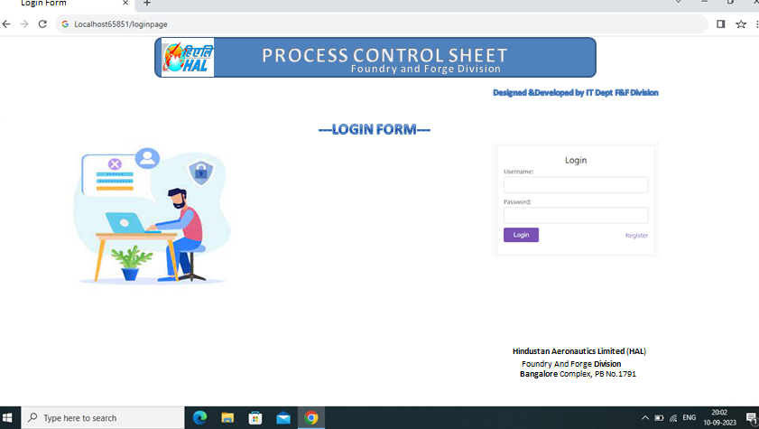

**FIGURE 5.1 LOGIN FORM**

The security or authentication credentials that are used to access the Website or the Software (where applicable) that may include a username, password and related account information.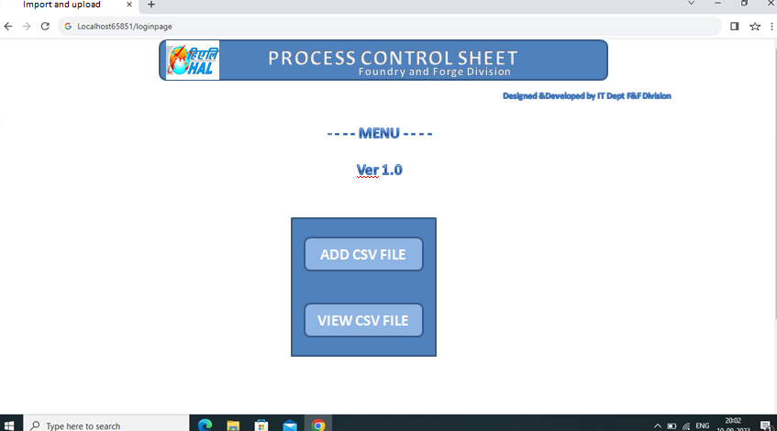

**FIGURE 5.2 MENU**

A document that defines and controls the methods of ensuring consistent production process

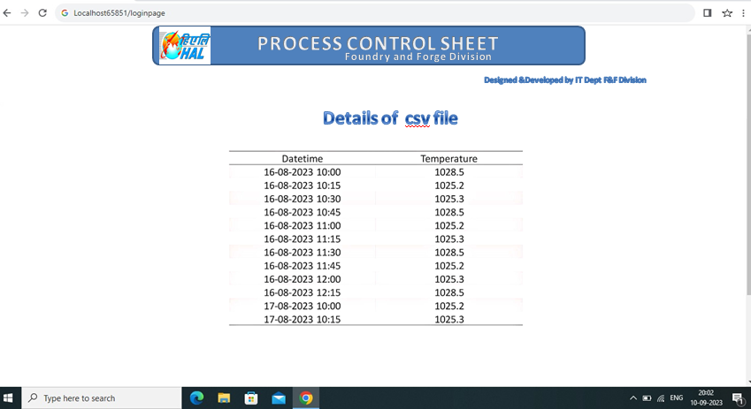

**FIGURE 5.3 DETAILS OF CSV FILE**

The database focuses on storing time and temperature data for your IoT-based Process Control

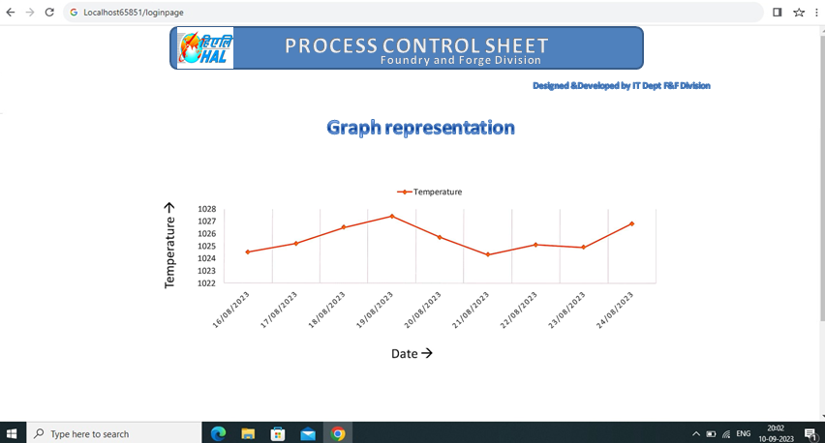

**FIGURE 5.4 GRAPH REPRESENTATION OF DATE vs TEMPERATURE**

It is visual representation for monitoring and controlling processes in an IoT-based Process Control Sheet (PCS) project. It helps in viewing and visualizing temperature fluctuations over time, aiding in real-time decision-making. When we click on a particular point on the graph, another graph of time/temperature is displayed for that particular date as shown in fig 5.5.

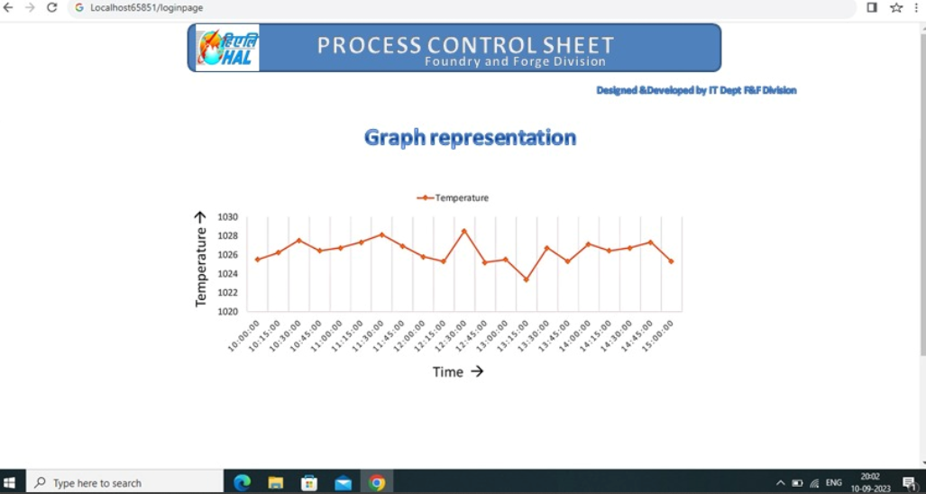

**FIGURE 5.5 GRAPH REPRESENTATION OF TIME vs TEMPERATURE**

CHAPTER 6

**CONCLUSION**

This is to say that the IoT-based Process Control Sheet (PCS) project has the potential to revolutionize manufacturing and industrial processes. By harnessing the power of IoT, data analytics, and real-time monitoring, organizations can achieve higher levels of quality and efficiency. The implementation of IoT sensors and devices combined with a robust database and analytics system empowers organizations to monitor manufacturing processes with unparalleled precision. This project leverages data analytics to transform raw sensor data into actionable insights. By visualizing and analyzing temperature and other critical parameters, operators and managers can make informed decisions to optimize processes and maintain product quality. The system facilitates regulatory compliance by maintaining detailed records of process data and events. It simplifies reporting for audits and regulatory inspections, ensuring adherence to industry standards. The project promotes a culture of continuous improvement by providing access to historical data for in-depth analysis. Organizations can identify trends, patterns, and opportunities for further optimization.

CHAPTER 7

**FUTURE ENHANCEMENT**

• Present system is developed in the .net technology. This system is helpful for real time data collection and historical data analysis for process optimization and quality improvement.

• Project can further improve its capabilities, expand its scope, and adapt to evolving industry trends.

• Enhance data analytics capabilities to perform more complex analysis, such as predictive modeling and optimization

• Remote monitoring solutions to allow operators and managers to access and control processes from anywhere, enhancing flexibility and responsiveness.

• Enable the project to manage and monitor processes across multiple sites or facilities, providing a centralized view of operations and streamlining management.

• Stay updated with the latest cybersecurity practices and technologies to safeguard against evolving threats and vulnerabilities.

• Stay up-to-date with evolving industry regulations and standards, ensuring that the PCS system continues to support compliance efforts.